A2026-Eur-Danube Rider Votive Plaque-Bronze-3rd c CE

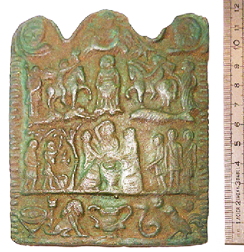

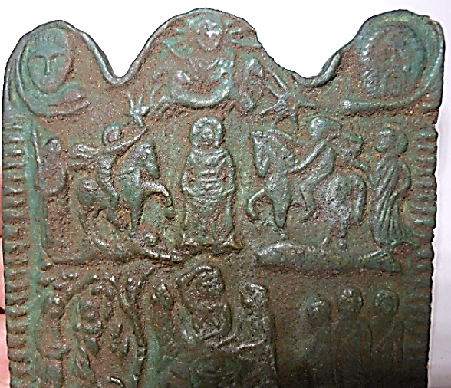

­­­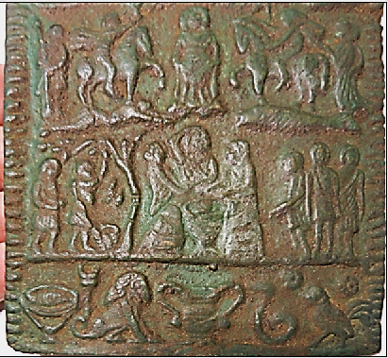

A000-Eur-Danube Rider Votive Plaque-Bronze-3rd c CE

**Case No.: 3**

**Accession No. A000**

**Formal Label:** A000-Eur-Danube Rider Votive Plaque-3rd c CE

**Display Description:**

The plaque contains a complex iconography of divine figures and symbols, probably associated with Thracian or Dacian beliefs of the Lower Danube region. Presiding over the whole scene is Sol Invictus (the invicible sun-god) in a quadriga (four-horse chariot). His cult originated in the Near East and gained increasing influence under imperial patronage during the third century CE. These votives seem to include themes seen in the Thracian and Danubian Rider images, as well as a central Goddess figure who has been argued to be the Celtic Goddess Epona, feeding horses, and the Danubian Rider.

This plaque is rectangular in shape and cast in relief. Two columns with Corinthian capitals and a double arch frame the scene, possibly forming a sanctuary; on the outside, in the top corners of the plaque, two snakes can be seen framing a young man and an aged man, the alpha and omega of life.

Within the central structure, we see Sol in his quadriga (a chariot with four horses) in the first register, with a crown of rays around his head, holding a globe in his left hand; over the horses of the quadriga two stars are shown, which have been interpreted as possibly the morning star and the evening star.

Central in the second register is a woman or goddess. She is lifting her garment, forming a sack to feed of the horses. The horses step on a fish (on the proper right hand side of the central figure) and a man lying on the ground (on her proper left-hand side).

The third register contains in the middle a couple of men (possibly priests, because on many of these plaques they are depicted boldly), grouped around a table with a fish (which has been explained as offertory meal); there are other figures in the same register.

In the fourth register we see a tripod table with fish on it, a kantharos (a symbol for water), a lion (a symbol for fire), a snake (a symbol for the earth) and a rooster (a symbol for the air).

**LC Classification:**

**Provenance:** Collection of Professor Rudolf Franz Ertl. He published part of his collection of cult plaques in the book Donaureiter – Bleivotivtafeln. Versuch einer Typologie (Wien, 1996). Reinhard Dollinger

45 Great Cumberland Place

W1H7DL Marble Arch, London

Großbritannien

**Discussion:**

The protector of horses, mules, and cavalry, Epona was one of the only non-Roman goddesses to have been wholly adopted by the Roman Empire.  Often depicted astride a horse, Epona resonated in the forces of the Roman cavalry as an inspiration and guide through even the darkest of battles, and she remained one of their most worshipped goddesses between the first and third centuries CE.

Interestingly, Epona was also seen as a goddess of fertility, accompanied in many of her depictions by grain or a cornucopia. Coupled with the worship of her equine prowess in the military, it is evident she was seen both in Gaulish and Roman cultures as a deity of prosperity within the equestrian home and on the battlefield.

It has also been argued that Epona served as an escort for souls into the afterlife. The presence of a statue of Epona in her horse form [**was found in the grave of a young girl**](http://www.huntspost.co.uk/news/the-roman-burial-that-offers-a-rare-glimpse-into-past-of-huntingdonshire-town-1-5301779)who died in the 2nd century and seems to support this notion. That burial was discovered in Godmanchester (Roman Durovigutum), in the Huntingdonshire district of Cambridgeshire, England.

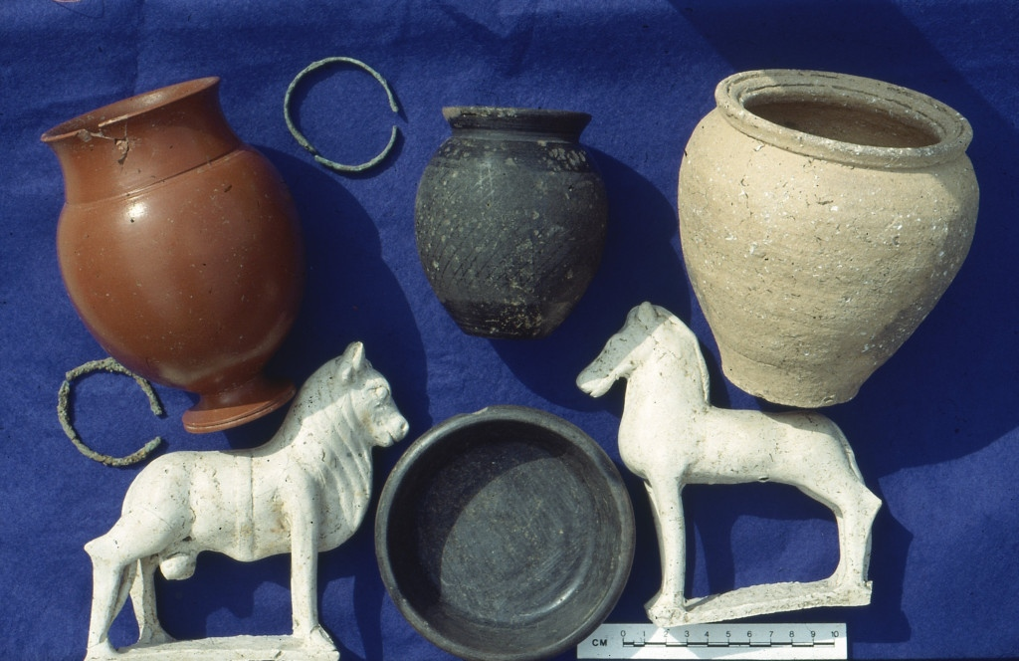

**erald Reeve’s cottage in Godmanchester sat on the site of a wealthy Roman settlement and he was used to finding treasures in his garden.**

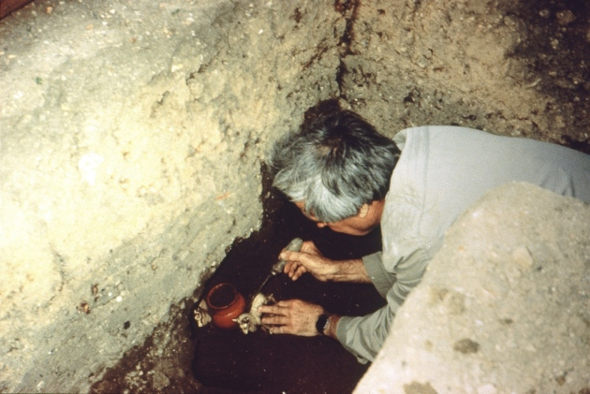Gerald Reeve unearthing the finds in his back garden. Picture: CONTRIBUTED

Most residents of the town were and still find them today.

The town’s Roman name is Durovigutum, the premier Roman town in the province and it has always been said that if you put your trowel in the ground you’re likely to find ancient treasure.

So it was for this reason Gerald dug carefully while starting foundations for his Pinfold Lane garage in 1991, and it was fortunate that he did because he unearthed a find of international significance.

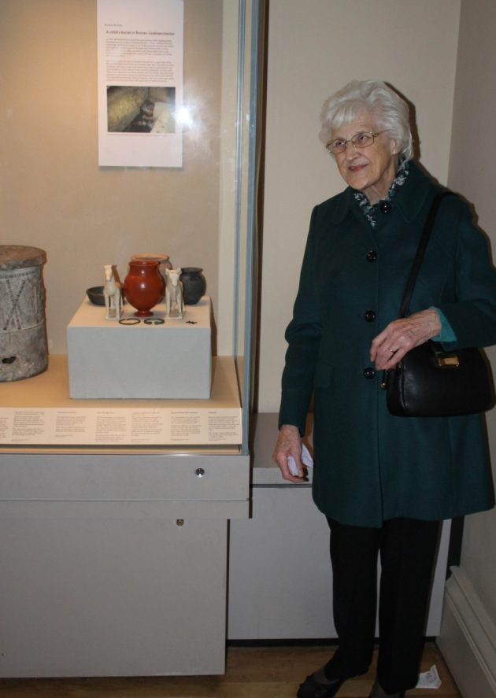Dorothy Reeve with the collection at the British Museum. Picture: CONTRIBUTED

Gerald happened upon the burial of a seven-year-old girl dating from the 2nd century AD, which had been embellished with imported pottery, bangles and figurines.

There was a rare red Samian ware vase imported from the Rhineland, flanked on either side by two white figurines, a horse and a bull, again, both imported, this time from Lezoux, in France.

“Dot,” he shouted to his wife, “Quick. Bring the camera”.

That picture taken in 1991 is now on show at the British Museum along with the items discovered in the burial, donated by Gerald’s widow, Dorothy, earlier this year.

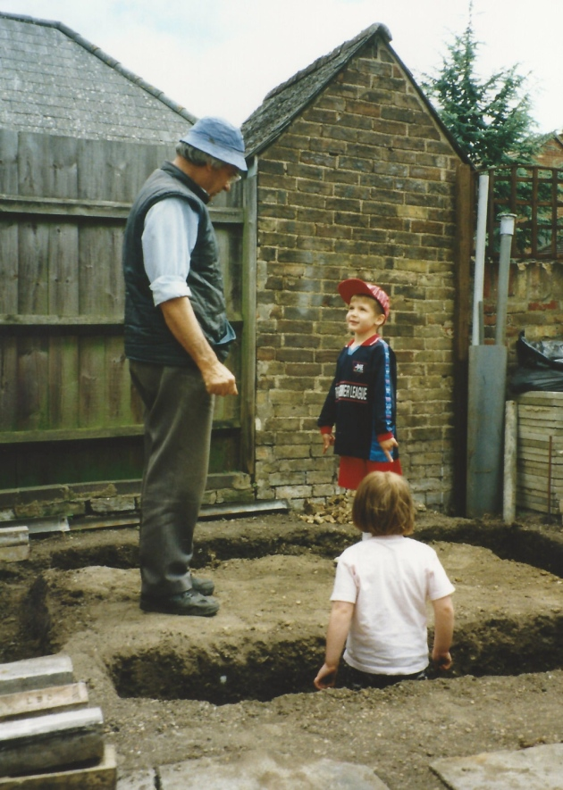Gerald Reeve unearthing the finds in his back garden. Picture: CONTRIBUTED

Gerald found a group of pots, figurines and bracelets, the poignant cremation burial of a Roman child.

In front of the red Samian ware cremation vessel which contained the child’s remains, was a black burnished ware drinking cup, perhaps containing a drink for her journey to the afterlife.

The sacred bull, which symbolised strength, has a symbolic sacrificial sash around its belly and would have been there to protect the child and impress the gods with her high status.

Behind the bull her parents had put a little a black burnished ware dish for sweets and at the back a buff coloured cooking pot so that she could have porridge in the afterlife.

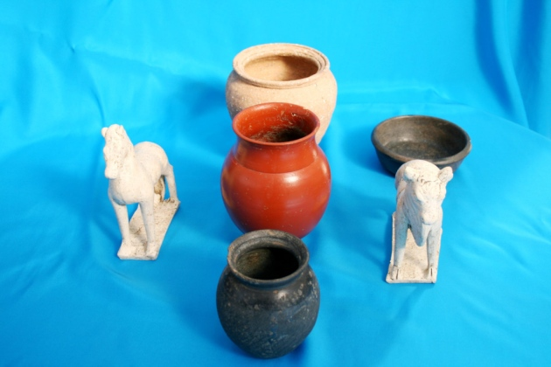The items discovered in the grave in Godmanchester. Picture: CONTRIBUTED

The horse figurine is that of the Romano Celtic goddess Epona, escorter of souls to the afterlife, also goddess of crossroads and goddess of cavalry too, which might indicate that the child’s father was Roman cavalry officer.

Sue Jones, Gerald’s daughter, said: “My father treasured this find and kept the little girl safe in a way. He only showed people the vessels and the bangles but kept the cremated remains private – perhaps for her sake.”

Gerald immediately showed his find to the Cambridgeshire county archaeologist, Alison Taylor, who verified that the child was about seven or eight-years-old, using bone analysis.

Sue said: “Alison was amazed by the rarity of the find, the rarity of the perfect figurines and Samian ware vase and became my dad’s friend. My father died some time ago, but he would have been pleased to see this lovely collection go to the British Museum.”

The burial group had been put in the ground in a wooden box as was the custom in Roman times. The wood rotted away, but two little gold box fittings used to close the lid had fallen into the cremation vessel.

Professor Stephen Upex, the Cambridge archaeologist who helped negotiate the collection’s place into the British Museum, said: “This burial is of international significance. Such perfect figurines are extremely rare, as is the Samian ware vessel, and everybody must be grateful to Gerald and Dorothy Reeve who ensured that the objects could be seen by as many people as possible”.

Rachel Jackson, from the British Museum, said: “The museum was grateful for the generous donation of the important and poignant child cremation burial. The bracelets, animal figurines and box fittings accompanying the child demonstrate the wealth of the family and the links abroad make it an unusual burial compared to other graves from Roman Britain.”

Professor Upex believes the costly items used in the burial were available to buy in Godmanchester, a wealthy, relatively sophisticated town in 2nd century AD, as there would not have been time to obtain them from abroad or even London.

Kate Hadley and Professor Upex have recently published Roman Secrets from Private Collections, a digital catalogue of votive Roman treasures from Godmanchester and Cambridgeshire.

After <https://www.huntspost.co.uk/news/the-roman-burial-that-offers-a-rare-glimpse-into-past-of-huntingdonshire-town-1-5301779>

Originally from Gaul, Epona was worshipped in Britain throughout the Iron Age, coming to the continent during the time of the Romans. As far as modern scholarship can tell, her worship extended as far north as the Strathclyde Region in Scotland, with depictions of her found on the Roman wall forts of Hadrian and Antonine, but her veneration stretched no further than the farthest reach of the Empire.  There is no evidence of Epona in the Near East - an understandable lack, as the Romans were never able to conquer or occupy the Persian Empire. It is unknown from where, exactly, Epona originated but she was prevalent throughout the tribes of the Celts and quickly became widespread throughout the Empire as well.

Epona made her way to Rome through the aid of the Roman military. The Roman cavalry was formed of foreign auxiliaries from groups and tribes conquered by the Empire.  Though many of these men were not citizens, citizenship could be attained after a certain number of years in the military, which meant that the Roman forces were exposed to foreign religions quite often and for long periods of time.  Even though Gauls were not one of the prominent groups in the cavalry, Epona was introduced to this amalgamation of men during their time fighting in Gaul. With so many men from so many different cultures gathered together with such a prestigious equestrian duty to perform, it is natural that they would desire their own religious spirit or guide. Upon discovering her impression in Gaul, Epona became the perfect choice.

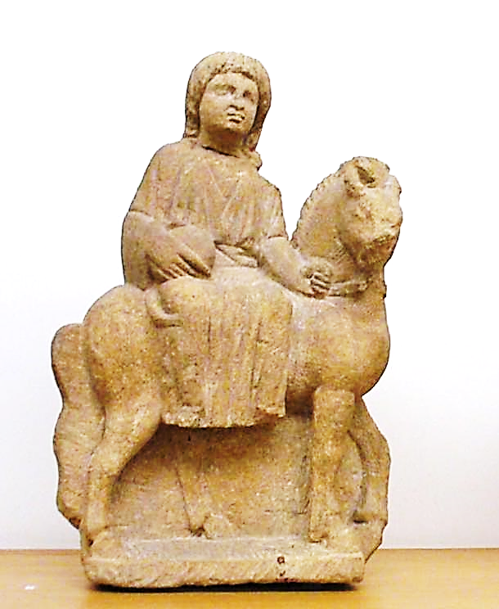

Small sculpture of the Roman/Celtic goddess Epona, third century CE. [**Public Domain**](https://commons.wikimedia.org/wiki/File:Luxembourg_MNHA_265_Epona_provenance_incertaine.jpg)

Epona was one of the gods of the Augustus Equites singulares, who were recruited among cavalry units located in the regions on the Rhine and the Danube. Epona's distribution throughout the realm was greatly aided by the fact that the Romans were already a religiously tolerant culture. Many gods of Gaul had been brought into the Empire by marrying Roman gods (as was the case with Mercury and Rosmerta) or by re-appropriating their names and affiliations to align with pre-existing Roman gods.

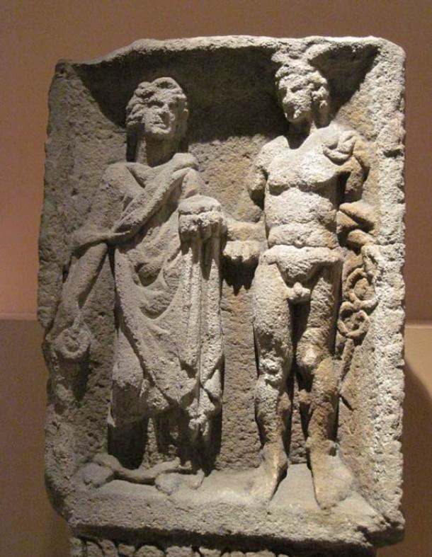

Relief of Mercury and Rosmerta from Eisenberg in present-day Rhineland-Palatinate. Wikimedia, ( ***[CC BY-SA 3.0)](https://commons.wikimedia.org/wiki/File:Mercurius_Rosmerta_HistMusPfalz_3513.jpg" \t "_blank)***

Epona is unique in that she was not renamed or married to a Roman husband—she came to Rome as herself and blended quite smoothly into the Roman military.  She is the only known Celtic deity to have been embraced in her original form by the Empire, with little adjustment made to her list of attributes. Her likeability spread outside of the military and into the homes of the Roman people as well.

The countryside of Rome consisted of widespread farmland, an environment that led to a need for a goddess who could protect and look over the stables and horses of the common people outside of the military.  As Epona was introduced into the city of Rome, her name and image spread like wildfire. Farmers, stable hands, grooms, drivers, and so many other ordinary people who interacted with horses and mules on a day to day basis welcomed Epona into their own lives and homes, and worshipped her as frequently as the Roman military.

She was revered in various ways throughout the region, depending on whether the worshipper was military or civilian. The cavalry erected small shrines wherever they went, which was one of the reasons why her cult was so widespread.  They sacrificed to her before important battles and wrote numerous vows and inscriptions to her.

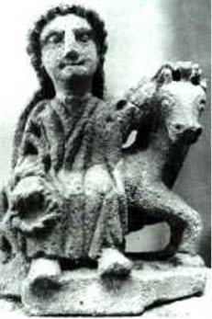

Small Epona sculpture from Auxois, France. [**Public Domain**](https://commons.wikimedia.org/wiki/File:Epona_Auxois.jpg)

In the home, there were more diminutive devices for her worship—tokens and flowers were laid out to her in countless equine locations, and small statues were often erected in houses and stables. It was on these statues that cornucopias were depicted, revealing the desire of the Roman people for her to bring fertility to their stables and strong mares to their herds. A good horse or donkey was an important source of transportation in ancient Rome—among the elite in particular, a strong horse was a valuable source of prestige.

Statues depicted Epona in three varying forms: astride her horse, as an imperial goddess, or riding upon a cart. It should be noted that in the Gaulish tradition, it was not customary to portray the gods in human form but rather in the form of an animal, plant, or other appropriate emblem of their worship.  Previous to the Romans, Epona was merely the image of a horse or mule. Upon coming to Rome, she was altered to appear as the Roman gods did, thus in the three aforementioned portray the gods in human form but rather in the form of an animal, plant, or other appropriate emblem of their worship.  Previous to the Romans, Epona was merely the image of a horse or mule. Upon coming to Rome, she was altered to appear as the Roman gods did, thus in the three aforementioned ways.

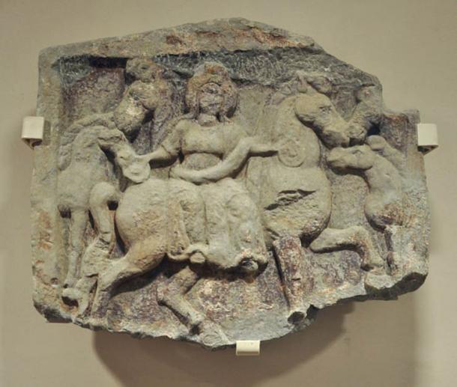

A relief depicting Epona and horses. Vorarlberg Museum, Bregenz, Austria. [**Public Domain**](https://commons.wikimedia.org/wiki/File:Epona-Relief_VLM.jpg)

Riding was the most common way in which Epona was shown, always sidesaddle and often with a cornucopia in her hands signifying both her fertility and that of the horses under her guidance. The imperial image portrays Epona in a more regal fashion, often standing between two to four horses and either standing or seated on a throne. Images such as these were undoubtedly inspired by the art of the Roman emperor and meant to show Epona as the sovereign of both equestrians and their owners.  The cart image has the least circulation and it shows Epona in a cart or chariot lead by horses. Interestingly, these images can be seen as a servile relationship between the goddess and her creatures which may (though there is little evidence) be the reason such depictions are few and far between.

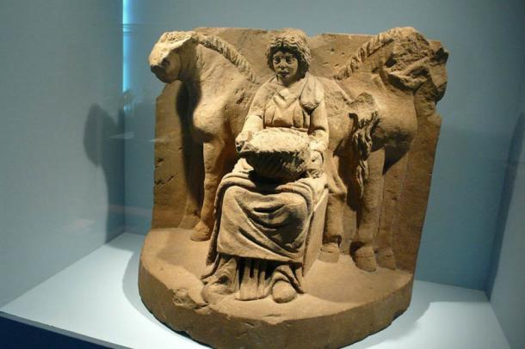

The motif of the "Lady of the Animals" lives on this religious depiction. Flanked by two horses, Epona is shown sitting on a throne holding a fruit basket on her lap. Circa 200 AD. Wikimedia, ( **[CC BY-SA 2.0](https://commons.wikimedia.org/wiki/Category:Epona" \l "mediaviewer/File:Epona.jpg" \t "_blank)**)

Epona is easily one of the most interesting goddesses assimilated into the Roman Empire. The apparent seamlessness and ease of her transition is only one of the reasons why she was such a fascinating addition to the culture of the Romans. She remains an example of the ways in which foreign gods were adopted into the Empire and the reasons for these adoptions. Furthermore, her fusion into the Empire allowed for rare extensive knowledge of her original Gaulish character and her subsequent alterations to be passed down for modern research.

Featured image: A relief of Epona, flanked by two pairs of horses, from Roman Macedonia, foruth century C.E. Wikimedia, ( **[CC BY-SA 3.0](https://commons.wikimedia.org/wiki/File:Epona_Salonica601_ArchMus.jpg" \t "_blank)**)

By [**Ryan Stone**](https://www.ancient-origins.net/users/ryan-stone)

**References:**

Adkins, L. and R. Adkins.1998.  Handbook to life in ancient Rome. Oxford:Oxford University Press.

Anon. 2015. "Epona Depictions." Epona.net- a Scholarly Resource. January 1, 2004. Accessed January 1, 2015. [**http://www.epona.net/depictions.html**](http://www.epona.net/depictions.html).

Bianconi, G. L. (1789) Descrizione dei Circhi particolarmente di quello di Caracalla e dei giuochi in essi celebrati.

Cattaneo, G. (1819). Equejade, monumento antico de bronzo del Museo nazionale ungherese considerato ne' suoi rapporti coll' antichità figurata. Milano, Imp. Regia stamperia. Fig. 3

Chevallier, Raymond (1998) Voyages et Déplacements dans l'Empire Romain. Armand Collin, Paris.

Collingwood, R.G.; Wright, R.P. 1965. The Roman Inscriptions of Britain (RIB) Oxford: Clarendon Press.

Dorow, W. (1826) Opferstätten und Grabhügel der Germanen und Römer am Rhein. Wiesbaden, II, p.28 and plate XIV

Ertl. Rudolf Franz 1996. Donaureiter – Bleivotivtafeln. Versuch einer Typologie. Wien.

Espérandieu, É. (1907) Recueil général des bas-reliefs de la Gaule romaine. Paris, Imprimerie nationale.

Hettner, F. (1876) Katalog des Königlich-Rheinischen Museums Vaterländischer Alterthümer bei der Universität Bonn. Bonn, p.79, #216

Irby-Massie, G. L. 1999. Military religion in Roman Britain. Leiden: Brill.

Joffroy, R. (1978). Découverte d'une cachette de bronzes gallo-romains à Champoulet (Loiret). Comptes rendus de l'académie des inscriptions et belles-lettres, Paris(CRAI): 795-806.

Linduff, Katheryn. 1979. Epona: A Celt among Romans. Brussels: Latomus.

Magnen, René; Thévenot , Emile (1953) Épona : déesse Gauloise des chevaux, protectrice des cavaliers.. Delmas, Bordeaux.

Reinach, Salomon (1895, 1898, 1899, 1902, 1903) Épona. Revue archéologique 1895, part 1, 113, 309. Addenda ibid 1898, part 2, 187; 1899, part 2, 61; 1902, part 1, 227; 1903, part 2, 348.

Schleiermacher, W. (1933) Studien an Göttertypen der römischen Rheinprovinzen. 23. Bericht der Römisch-Germanischen Kommission.

Speidel, M. P. 1994. Riding for Caesar: the Roman Emperors' Horse Guards. Cambridge: Harvard University Press.

Szilágyi János György (2001) Antik művészet - vezető az Antik Gyűjtemény állandó kiállításához, Budapest: Szápművészeti Múzeum.

Woolf, G. Becoming Roman: the origins of provincial civilization in Gaul (Cambridge University Press: Cambridge, 1998.)